Roll No.: _ _ _ _ _ _ _ _ _ _ _ _ _ _ _ _ _ _ _

Amrita Vishwa Vidyapeetham

B.Tech. First Assessment – August 2019

First Semester

Common to all Engineering Departments

19CSE100 Problem Solving and Algorithmic Thinking

**Set-2**

Time: Two hours Maximum: 40 Marks

**Course Outcomes (COs):**

|  |  |
| --- | --- |
| **CO#** | **Course Outcomes** |
| CO1 | Apply algorithmic thinking to understand, define and solve problems |
| CO2 | Understand an algorithm by tracing its computational states, identifying bugs and correcting them |
| CO3 | Apply the basic programming constructs for problem solving |
| CO4 | Design and implement algorithm(s) for a given problem |

**Answer all questions**

**Part A (20 Marks)**

1. The "*Secret Number Game*" is a classic game where the player attempts to guess a number usually between 1 and 100. The secret number is generated with the function random. The random(num) will generate a random number in the range 0 to num–1. The following *incomplete* flowgorithm implements the secret number game. Note that random(100) + 1 generates a random number in the range 1 to 100. Complete the flowgorithm by placing appropriate statements. Can you think of any *effective* strategy while making guesses to win this game? [5 Marks][CO2]

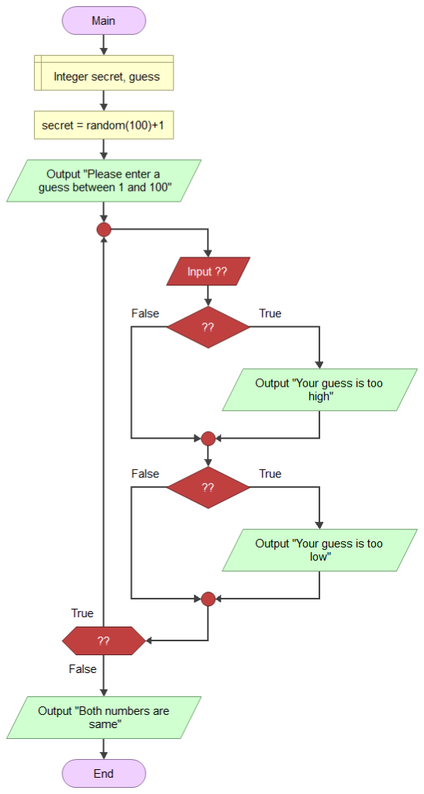

Solution: (Each missing statement gets 1 mark each). A guess that reduces the search space by half will be an effective strategy to win this game. [1 mark]

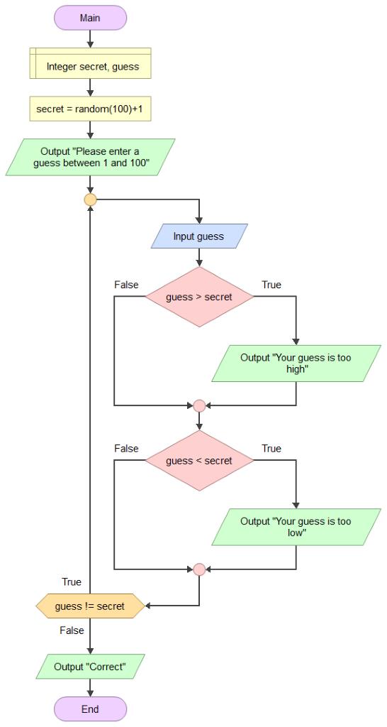

1. There are two Jeroos. As shown in the following figure (left), Jeroo1 starts at (0, 0) facing North with one flower in its pouch. Jeero2 starts at (0, 2) facing East with one flower in its pouch. There is a net at location (3, 2). Given below is a (jumbled) pseudocode that directs Jeroo1 to give its flower to Jeero2. After receiving the flower, Jeroo2 must disable the net, and plant a flower in its place. After planting the flower, Jeroo2 must turn and face South (as shown in the right figure). There are no other nets, flowers, or Jeroos on the island. Rewrite the pseudocode in the right order to achieve the above said goal. [5 Marks][CO1]

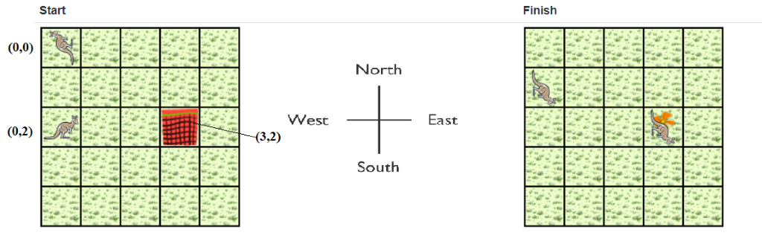

* 1. Give a flower to Jeroo2. Go ahead
  2. Jeroo2:Hop twice (to location (2, 2)). Disable the net
  3. Turn right
  4. Jeroo1 Turn around (either left or right twice) Hop (to location (0, 1))
  5. Jeroo 2: Hop (to location (3, 2)) Plant the flower

Solution: [1 Mark for each statement at right position]

* 1. Jeroo1 Turn around (either left or right twice) Hop (to location (0, 1))
  2. Give a flower to Jeroo2. Give ahead
  3. Jeroo 2:Hop twice (to location (2, 2)) Disable the net
  4. Jeroo 2:Hop (to location (3, 2)) Plant the flower
  5. Turn right

1. Given the following flowgorithm [5 Marks] [CO2]
   1. How many times the loop in the flowgorithm will execute?
   2. What will be the value of sum at the end of the flowgorithm?
   3. Rewrite the flowgorithm by replacing the loop with the *while* loop. After rewriting the flowgorithm what will be the value of sum then?

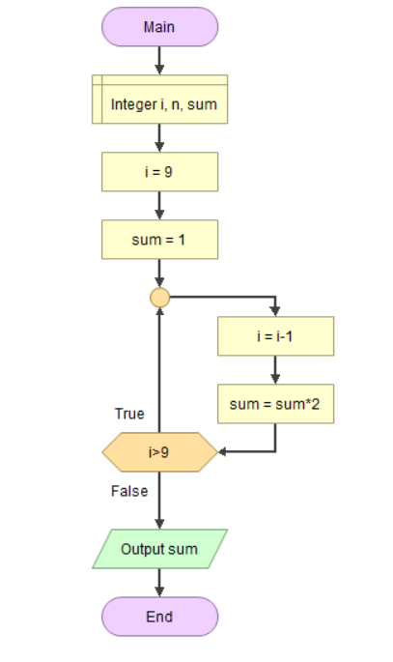

Solution:

A) The loop will get executed only once. [1 mark]

B) sum = 2 [1 mark]

C) sum = 1. [1 mark] The decrement statement becomes i=i-9 [while loop 3 marks]

1. The goal of the following flowchart is to put a zero in the boxes numbered 2, 4 and 6. In order to accomplish exactly this – no more and no less, which number must be in box 3 to make the flowchart meet its goal? Explain your answer [5 marks] [CO2].

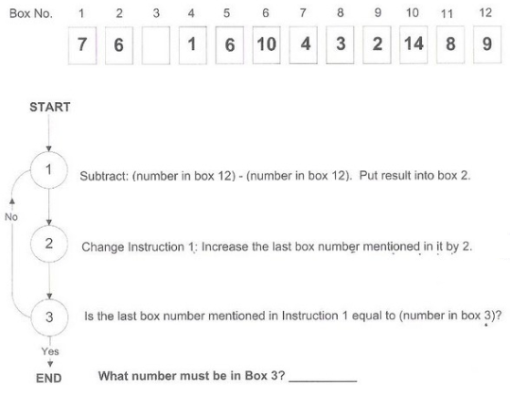

Solution

A) Box 3 should contain 8 [2 marks]

B) On each loop, the box 2, 4, 6, 8, 10... gets filled with 0. We need to limit it until 6 only. When the last box count becomes 6, we need to execute the instruction. So, box 3 should not have 6. After executing instruction, it updates the box number to 8. Here, we need to break. So, box 3 should contain 8. [3 marks]

**Part B (20 Marks)**

1. Write a flowgorithm to find the smallest number that is completely divisible by all numbers from 1 to n. For example, 2520 is the smallest number that can be divided by each of the numbers from 1 to 10 without any remainder. 12 is the smallest number that is completely divisible by all numbers from 1 to 4. As a matter of fact, given any n, can your program find the appropriate smallest number that is evenly divisible by all numbers from 1 to n?! [10 Marks][CO3]
2. Given a positive integer n, the task is to check if n is a *non-hypotenuse* number or not. If n is a non-hypotenuse number, then print ‘YES’ else print ‘NO’. In mathematics, a *non-hypotenuse* number is a natural number whose square cannot be expressed as sum of two distinct non-zero squares. The number 1, 2, 3 and 4 are non-hypotenuse numbers while 5 is not. [10 Marks][CO3]

Input: 5

Output: No (Explanation: 52 can be expressed as 32 + 42)

Input: 6

Output: YES (Explanation: 6 cannot be expressed as sum of two different squares.)

Input: 10

Output: NO (because 82 + 62)

Input: 13

Output: NO (because 122 + 52)